Sample Document
Author1 Name
Authors affiliation, no@spam
Author2 Name
Authors affiliation, no@spam

Abstract
This is a sample input file. Comparing it with the output it generates can show you how to produce a simple document of your own.

Keywords. Datacentre design, energy efficiency of datacentre, energy efficient metrics, carbon footprint computation.

Introduction
Energy efficiency and low carbon strategies have attracted a lot of concern. The goal for 20% energy efficiency and carbon reduction by 2020 drove the Information Communication Technologies (ICT) sector to strategies that incorporate modern designs for a low carbon and sustainable growth (Open, 2008). The ICT sector is part of the 2020 goal and participates in three different ways. In the direct way, ICT are called to reduce their own energy demands (green networks, green IT), in the indirect way ICT are used for carbon displacements and in the systematic way ICT collaborate with other sectors of the economy to provide energy efficiency (smartgrids, smart buildings, intelligent transportations systems, etc.). ICT and in particular data centers have a strong impact to the global CO₂ emissions. Moreover, an important part of the OPEX is due to the electricity demands. This paper presents the sources and challenges that have to be addressed to reduce carbon emissions and electricity expenses of the sector.
Taking into consideration this ratio, green IT technologies have important benefits in terms of:
- Reduce electricity costs and OPEX
- Improve corporate image
- Provide sustainability
- Extend useful life of hardware
- Reduce IT maintenance activities
- Reduce carbon emissions and prevent climate change
- Provide foundations for the penetration of renewable energy sources in IT systems.

Data Center Infrastructure and Power Consumption
The overall design of a data center can be classified in 4 categories Tier I-IV each one presenting advantages and disadvantages related to power consumption and availability (Deboosere et al., 2007).
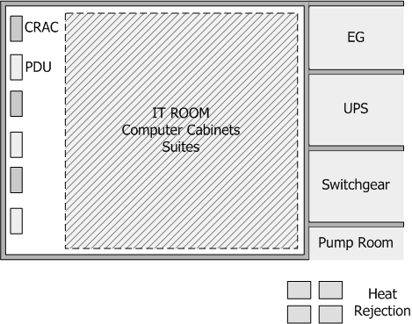
Figure 2.1. Typical Data Center Infrastructure
Source: Vereecken et al., 2009, p. 32
In most cases availability and safety issues yield to redundant N+1, N+2 or 2N data center designs and this has a serious effect on power consumption. According to Figure 2.1, a data center has the following main units.
At the following table (Table 2.1) the estimated consumption of a typical data center infrastructure is presented.
Table 2.2. Typical Data Center Infrastructure
Source: Koutitas & Demestichas, 2009, p. 23
Equipment Type | Est. Consumption 2007 (GW) | Est. Annual growth rate
Data centers | 26 | 12%
Pcs | 28 | 7,5%
Network Equioment | 22 | 12%
TVs | 40 | 9%
Others | 40 | 5%
Total | 156

2.1 Power Consumption

2.1.1 Power Consumption in Data Centers
Οf their maximum capacity workloads, the efficiency of the UPS cannot be considered constant and equal to the imposed by the manufacturer value (Wu and Li, 2015).
In general energy efficiency in the telecommunication industry is related to
(2.1)
The optimal description of this value depends on the system’s characteristics and the type of equipment. As an example, for modulation and coding techniques in wireless communications the spectral efficiency is a common measure. For electronic components the ratio of joule per bit best describes performance. In telecommunication networks and datacenters the ratio of watts consumed over the Gbps of data processed is preferred. In Cerutti et al. (2010) an absolute energy efficiency metric is introduced, named as dBε. The metric is computed according to the equation (2.2).
(2.2)

References
Bruen, M. (2020). River flows. In: Kelly-Quinn, M. and Reynolds, J., eds. Ireland’s rivers. Dublin: University College Dublin Press, pp.39-59.
Cameron, S. (2021). The business student's handbook: skills for study and employment. 7th ed. Harlow: Pearson.
Dundalk Institute of Technology. (2022). Research support[online]. Available from: https://www.dkit.ie/research/research-support.html [accessed 25 March 2022].
Levine, L.E. and Munsch, J. (2021). Child development: an active learning approach [online]. 4th ed. London: SAGE. Available from: https://books.google.ie/books?id=zlrZzQEACAAJ&dq [accessed 25 March 2022].
Tesseur, W. (2022). Translation as inclusion? An analysis of international NGOs’ translation policy documents. Language Problems and Language Planning [online], 45(3), pp. 261-283.
Theaker, A., ed. (2012). The public relations handbook. Abingdon: Routledge.

