Sample Document
Author1 Name
Authors affiliation, no@spam
Author2 Name
Authors affiliation, no@spam

Abstract
This is a sample input file. Comparing it with the output it generates can show you how to produce a simple document of your own.
Keywords. Datacentre design, energy efficiency of datacentre, energy efficient metrics, carbon footprint computation.

Introduction
Energy efficiency and low carbon strategies have attracted a lot of concern. The goal for 20% energy efficiency and carbon reduction by 2020 drove the Information Communication Technologies (ICT) sector to strategies that incorporate modern designs for a low carbon and sustainable growth (Open, 2008). The ICT sector is part of the 2020 goal and participates in three different ways. In the direct way, ICT are called to reduce their own energy demands (green networks, green IT), in the indirect way ICT are used for carbon displacements and in the systematic way ICT collaborate with other sectors of the economy to provide energy efficiency (smartgrids, smart buildings, intelligent transportations systems, etc.). ICT and in particular data centers have a strong impact to the global CO₂ emissions. Moreover, an important part of the OPEX is due to the electricity demands. This paper presents the sources and challenges that have to be addressed to reduce carbon emissions and electricity expenses of the sector.
Taking into consideration this ratio, green IT technologies have important benefits in terms of:
- Reduce electricity costs and OPEX;
- Improve corporate image;
- Provide sustainability;
- Extend useful life of hardware;
- Reduce IT maintenance activities;
- Reduce carbon emissions and prevent climate change;
- Provide foundations for the penetration of renewable energy sources in IT systems.

Data Center Infrastructure and Power Consumption
The overall design of a data center can be classified in 4 categories Tier I-IV each one presenting advantages and disadvantages related to power consumption and availability (Deboosere et al., 2007).
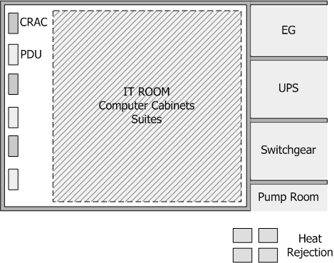
Figure 2.1. Typical Data Center Infrastructure
Source: Vereecken et al, 2009.
In most cases availability and safety issues yield to redundant N+1, N+2 or 2N data center designs and this has a serious effect on power consumption. According to Figure 2.1, a data center has the following main units.
At the following table (Table 2.1) the estimated consumption of a typical data center infrastructure is presented.
Table 2.2. Typical Data Center Infrastructure
Equipment Type | Est. Consumption 2007 (GW) | Est. Annual growth rate
Data centers | 26 | 12%
Pcs | 28 | 7,5%
Network Equioment | 22 | 12%
TVs | 40 | 9%
Others | 40 | 5%
Total | 156
Source: Koutitas & Demestichas, 2009.

2.1 Power Consumption

2.1.1 Power Consumption in Data Centers
Οf their maximum capacity workloads, the efficiency of the UPS cannot be considered constant and equal to the imposed by the manufacturer value (Wu and Li, 2015).
In general energy efficiency in the telecommunication industry is related to
(2.1)
The optimal description of this value depends on the system’s characteristics and the type of equipment. As an example, for modulation and coding techniques in wireless communications the spectral efficiency is a common measure. For electronic components the ratio of joule per bit best describes performance. In telecommunication networks and datacenters the ratio of watts consumed over the Gbps of data processed is preferred. In Cerutti, Valcarenghi and Catoldi (2010) an absolute energy efficiency metric is introduced, named as dBε. The metric is computed according to the equation (2.2).
(2.2)

References
Cerutti, I., Valcarenghi, L. and Castoldi, P., 2010. Designing Power-Efficient WDM Ring Networks, In: Doulamis, A., Mambretti, J., Tomkos, I. and Varvarigou, T. (eds) Networks for Grid Applications. GridNets 2009. Lecture Notes of the Institute for Computer Sciences, Social Informatics and Telecommunications Engineering, Springer, Berlin, Heidelberg, pp. 101-108.
Deboosere, L., De Wachter, J., De Turck, F., Dhoedt, B. and Demeester, P., 2007. Thin Client Computing Solutions in Low-and High-Motion Scenarios, In: International Conference on Networking and Services (ICNS '07), 19-25 June 2007, Athens, pp. 38-38, DOI: 10.1109/ICNS.2007.115.
Open, C.T,. 2008. The Climate Group SMART (2020): Enabling the low carbon economy in the information age, GeSi [online] Available at: https://gesi.org/research/smart-2020-enabling-the-low-carbon-economy-in-the-information-age [Accessed 08 February 2009].
Vereecken W., Deboosere, L., Simoens, P., Vermeulen, B., Colle, D., Develder, C., Pickavet, M., Dhoedt, B. and Demeester, P., 2010. Energy Efficiency in Thin Client Solutions. In: Doulamis A., Mambretti J., Tomkos I., Varvarigou T. (eds) Networks for Grid Applications. GridNets 2009. Lecture Notes of the Institute for Computer Sciences, Social Informatics and Telecommunications Engineering, Springer, Berlin, Heidelberghttps://doi.org/10.1007/978-3-642-11733-6_12, pp. 109-116.
Wu, G. and Li, G.Y., 2015. Recent advances in energy-efficient networks and their application in 5G systems. IEEE Wireless Communications, 22(2), pp.145-151.

